ASSIGNMENT-20.5
Name:D.Sreeja
H NO:2303A51664
Batch-14
Task 1 – Password Storage Vulnerability Check Task:
Analyze an AI-generated signup script for insecure password storage.
Expected Output:
• A secure registration script with hashed password storage.
PROMPT:
Generate a Python user registration script that stores username and password in a file or database without using hashing
CODE
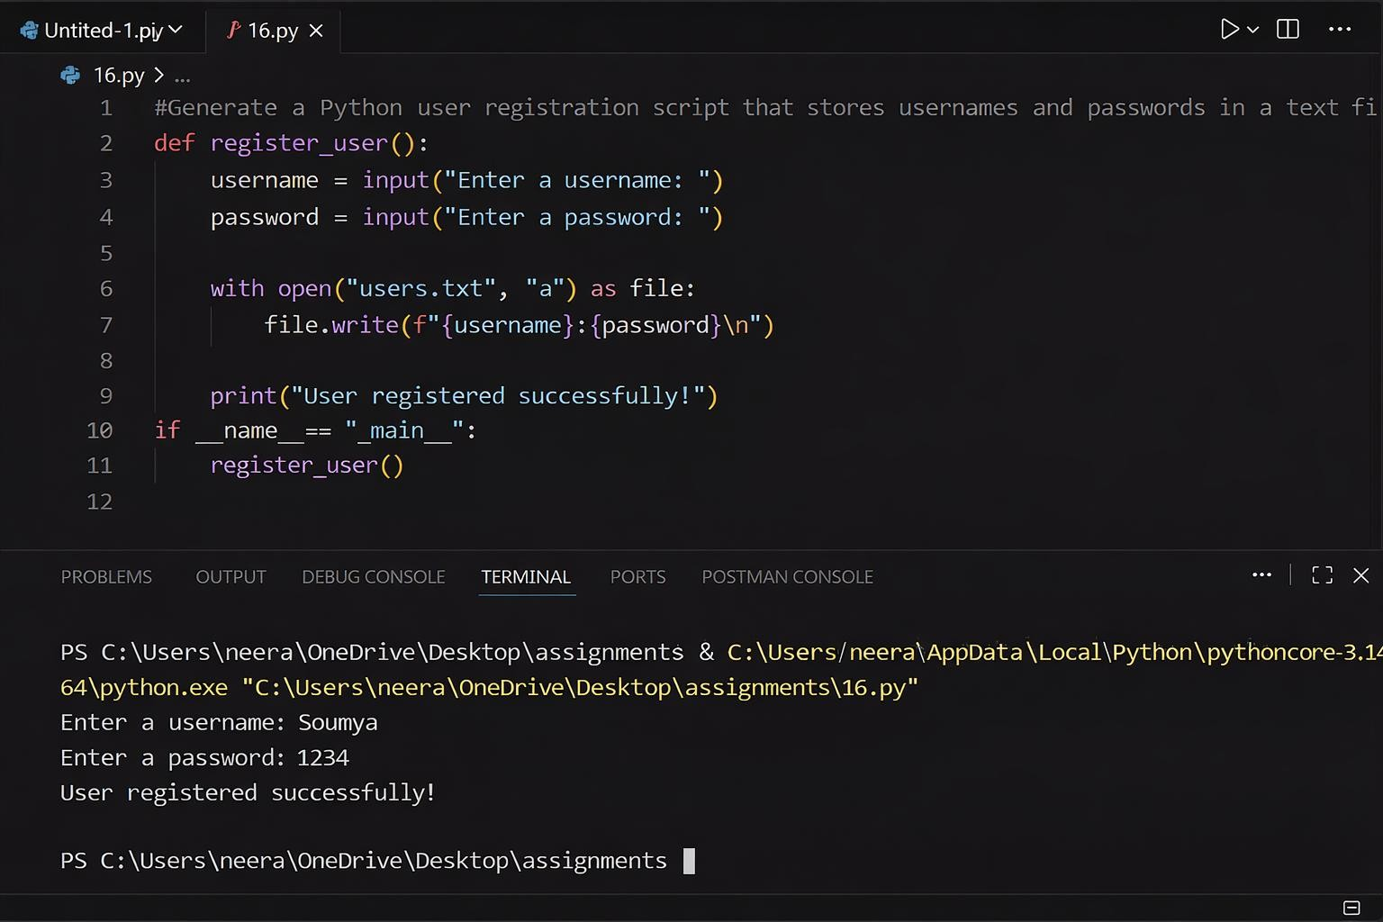
JUSTIFICATION:
The AI-generated script stores passwords in plain text, which is insecure because anyone with access to the file can easily read user credentials. This creates a major security risk, especially if sensitive data is involved. To improve security, passwords should be converted into a hashed format using libraries like hashlib or bcrypt.
Task 2 – Hardcoded Secrets Detection Task:
Evaluate AI-generated code for hardcoded API keys or credentials.
Instructions:
- Ask AI to generate a script that connects to an external API.
- Identify if API keys/passwords are written directly in code.
- Refactor using environment variables or config files.
Expected Output:
- A secure script with secrets managed properly.
PROMPT:
Generate a Python script that connects to an external API using a hardcoded API key or credentials in the code.
JUSTIFICATION:
The AI-generated script include API keys or credentials directly in the code, which is insecure because anyone accessing the code can misuse them. Hardcoding secrets increases the risk of unauthorized access and data breaches. To improve security, sensitive information should be stored in environment variables or configuration files. This ensures that credentials are protected and not exposed in the source code.

CODE:
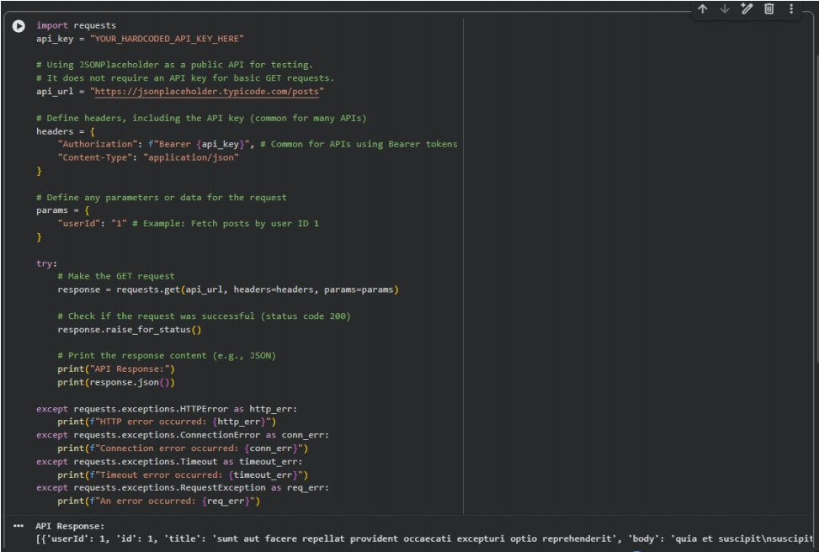
Task 3 – File Upload Security Validation Task:
Test an AI-generated file upload program for unsafe file handling.
Instructions:
- Prompt AI to generate a Flask file upload example.
- Check for vulnerabilities like uploading executable files.
- Add validation for file type, size, and secure filename handling.
Expected Output:
- A secure file upload implementation.
PROMPT:
Generate a simple Flask application that allows users to upload files without any validation or restrictions.
CODE
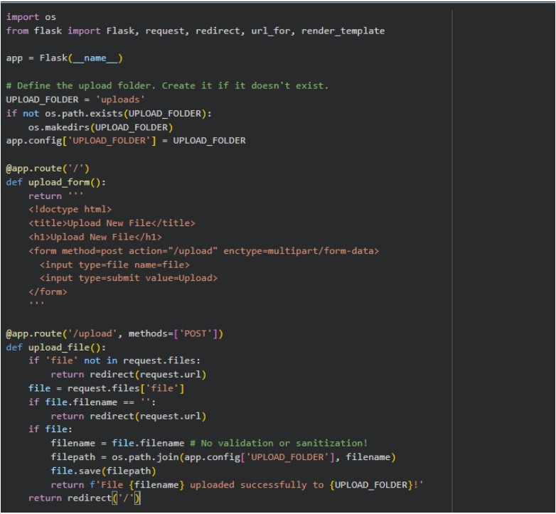
JUSTIFICATION:
The AI-generated Flask file upload program allows files to be uploaded without any validation, which can be dangerous. Users might upload harmful files like scripts or executables that could affect the system. There are no checks for file type, size, or filename, increasing security risks. To make it secure, validation should be added to allow only specific file types, limit file size, and use secure filenames. This helps prevent malicious uploads and protects the application.

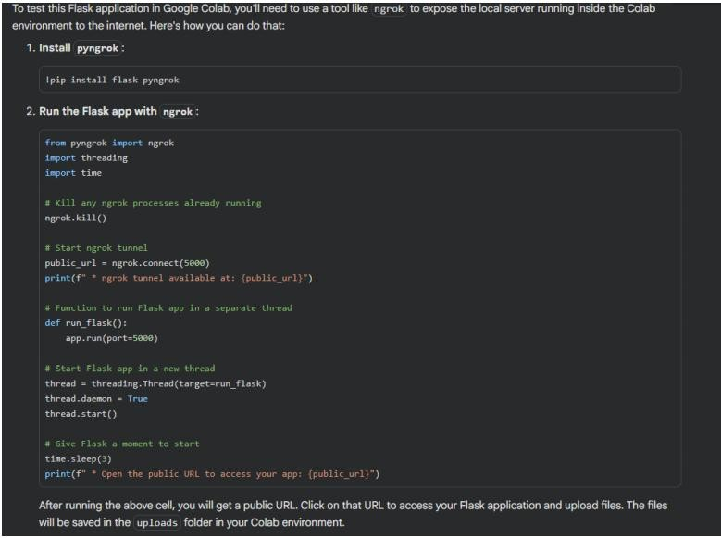
Task 4 – Command Injection Prevention Task:
Analyze an AI-generated Python script that executes system commands.
Instructions:
- Ask AI to generate code using os.system() or subprocess.
- Identify command injection risks with user input.
- Fix using safe subprocess calls and input validation.
Expected Output:
- A secure command execution script.
PROMPT:
Generate a Python script that takes user input and executes it as a system command using os.system() or subprocess.
CODE
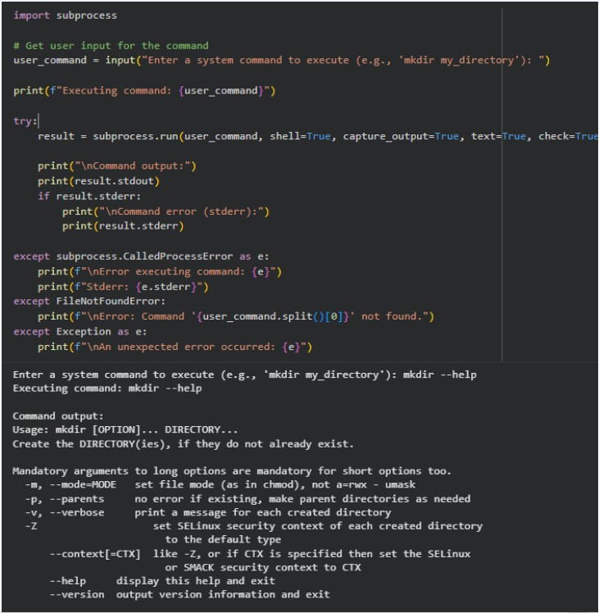
JUSTIFICATION:
The AI-generated script executes user input directly as a system command, which is unsafe and can lead to command injection attacks. Malicious users can input harmful commands that may damage the system or access sensitive data. This makes the program highly vulnerable to security breaches. To fix this, user input should be validated and safer methods like subprocess with controlled arguments should be used. This ensures that only intended commands are executed and reduces security risks.
Task 5 – Secure Input Handling in Web Forms Task:
Check AI-generated web form code for improper input validation.
Instructions:
- Ask AI to generate an HTML + Flask feedback form.
- Identify missing validation and unsafe rendering.
Expected Output:
- A secure form resistant to injection attacks.
PROMPT:
Generate a basic HTML and Flask feedback form that accepts user input and displays it without validation or sanitization.
CODE
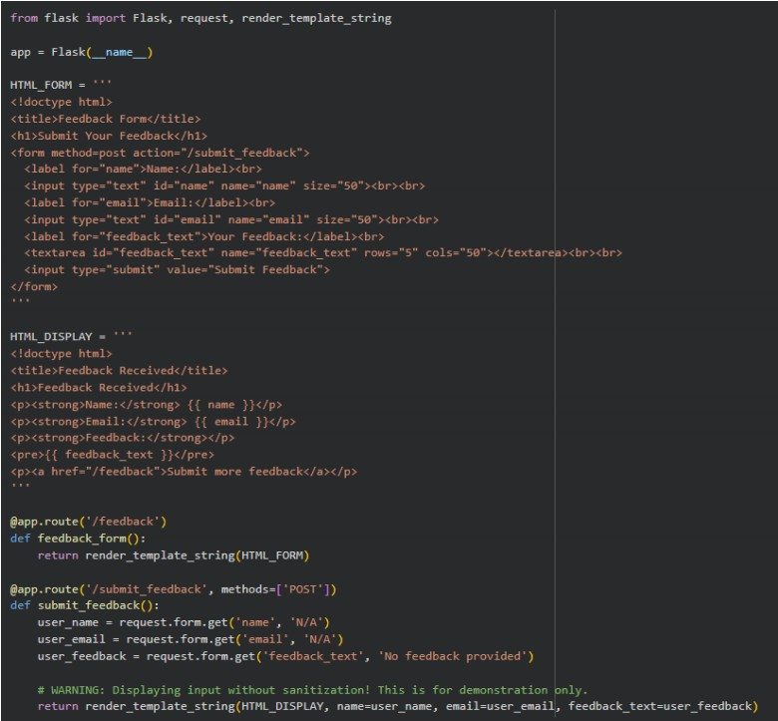
JUSTIFICATION:
The AI-generated script executes system commands directly using user input, which creates a serious security vulnerability. Attackers can inject malicious commands that may harm the system or access sensitive data. This lack of input validation makes the application unsafe and unreliable. To prevent this, safer methods like subprocess.run() with controlled arguments should be used instead of os.system(). Additionally, validating and restricting user input ensures that only intended commands are executed, improving overall security.

